Section A
- What is the functional group of the carboxylic acids?
Tick ( ) one box.
- -COOH | 
- -COH
- -C=O

- Choose the chemical formula of methanoic acid?
Tick ( ) one box.
- CH₃COOH
- HCOOH
- COOH

- Complete the structural formula for propanoic acid:

C C C

- Complete these word equations for reactions of carboxylic acids:

- ______________ acid + calcium calcium methanoate + ____________

- Propanoic acid + ______________ oxide sodium propanoate + _____________

- Butanoic acid + potassium carbonate potassium butanoate + _____________ + ________

Section B

- The table below gives some information about carboxylic acids.

Name | Chemical formula | pH (of 0.01 mol/dm³) solution
Methanoic acid |  | 2.9
Ethanoic acid | CH₃COOH | 3.4
 | C₂H₅COOH | 3.5

- Complete the table above.

A student adds zinc carbonate powder to a solution of ethanoic acid in an open conical flask, placed on a mass balance.

- Explain what would happen to the mass of the flask and contents during the reaction.

__________________________________________________________________________________________
__________________________________________________________________________________________
__________________________________________________________________________________________
__________________________________________________________________________________________

- Explain how this would be different if the student had added zinc oxide powder instead of zinc carbonate.

__________________________________________________________________________________________
__________________________________________________________________________________________
__________________________________________________________________________________________
__________________________________________________________________________________________

- Calculate the relative formula mass of ethanoic acid.

__________________________________________________________________________________________
__________________________________________________________________________________________

- Calculate the percentage by mass of carbon in ethanoic acid.

__________________________________________________________________________________________
__________________________________________________________________________________________

- The diagrams below show the structural (displayed) formulae of two organic compounds.

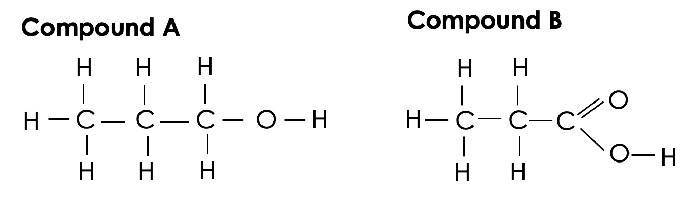

- Explain what is meant by an organic compound.

__________________________________________________________________________________________
__________________________________________________________________________________________

- Name compounds A and B.

__________________________________________________________________________________________
__________________________________________________________________________________________

- Both compounds are colourless liquids. Describe a simple chemical test that could be done in a test tube to determine which compound is which.

__________________________________________________________________________________________
__________________________________________________________________________________________
__________________________________________________________________________________________
__________________________________________________________________________________________

Section C

- (HT) Carboxylic acids are weak acids.
- Define a weak acid.
- Give an example of a strong acid.
- Compare the pH of a weak and strong acid with the same concentration.
- Compare the pH of a dilute and concentrated sample of the same acid.
- Calculate the concentration (in mol/dm³) of 5 g of hydrochloric acid dissolved in 100 cm³ of solution. Round your final answer to two decimal places.

